# **Data Model Design for Restaurant Management System**

**OLTP Schema Design:**

The OLTP schema is designed to have 6 tables Bills, Order, Menu, Customer, Feedback and Order Details. In this design, order details is an associative entity.

**Please find the screenshot of OLTP Schema Design below (Navicat):**

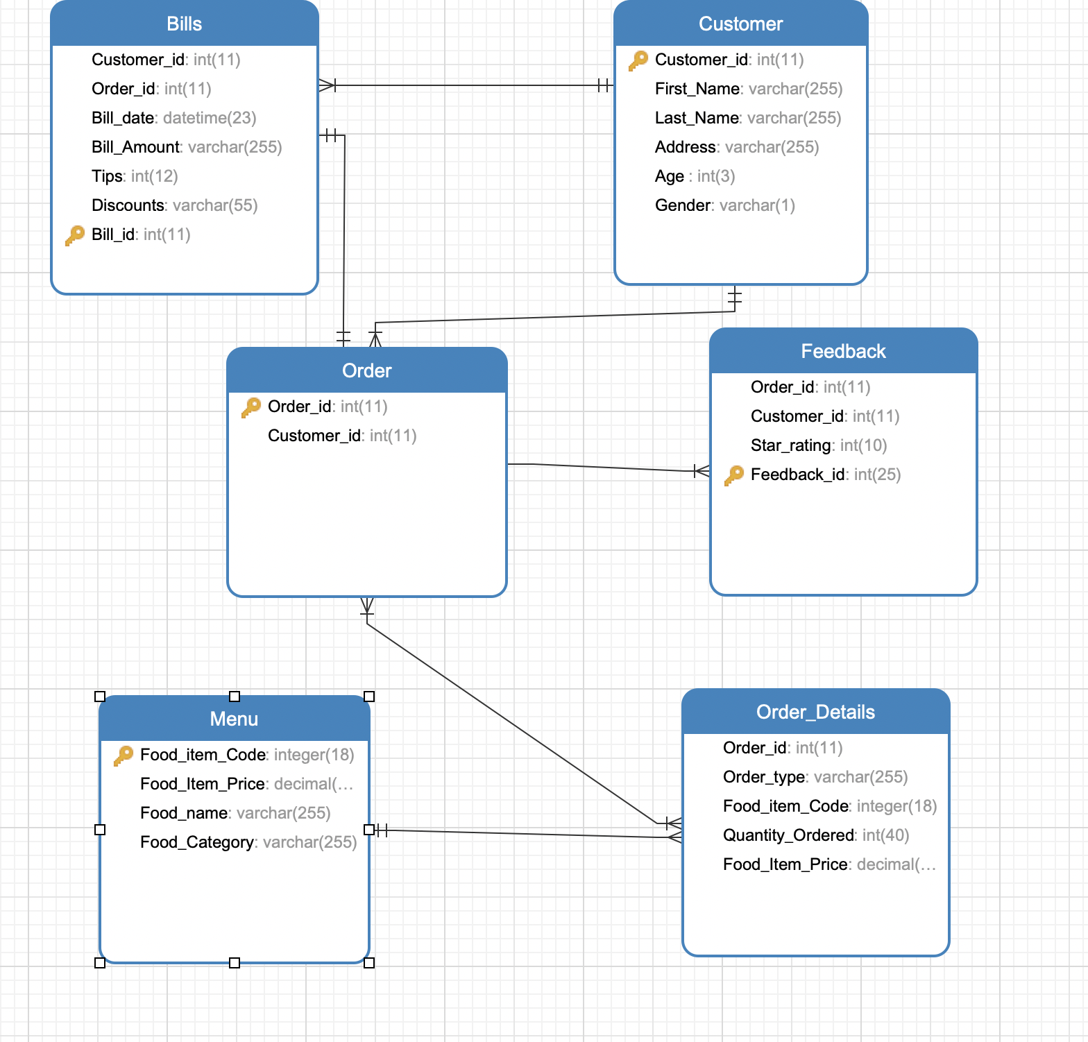

**Overall Screenshot in Navicat:**

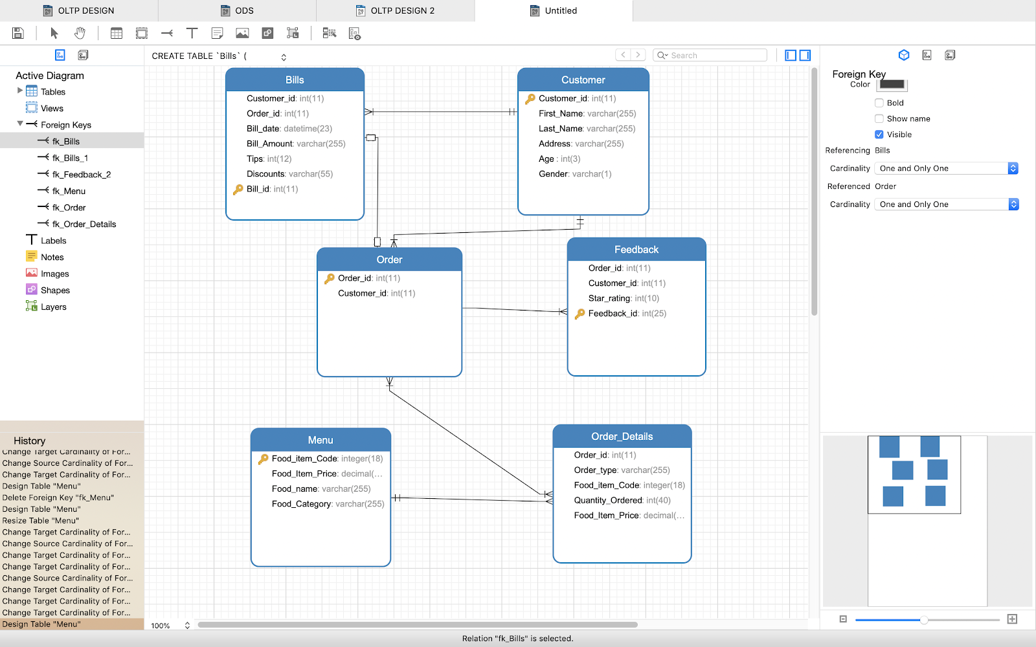

**ODS Schema:** In ODS Schema, there are 5 tables Customer, Orders, Menu, Bills and Feedback. Order and Order Details from OLTP schema is merged into one table as a preparation to convert the OLTP schema into OLAP schema

**Please find the screenshot of ODS Schema Design below:**

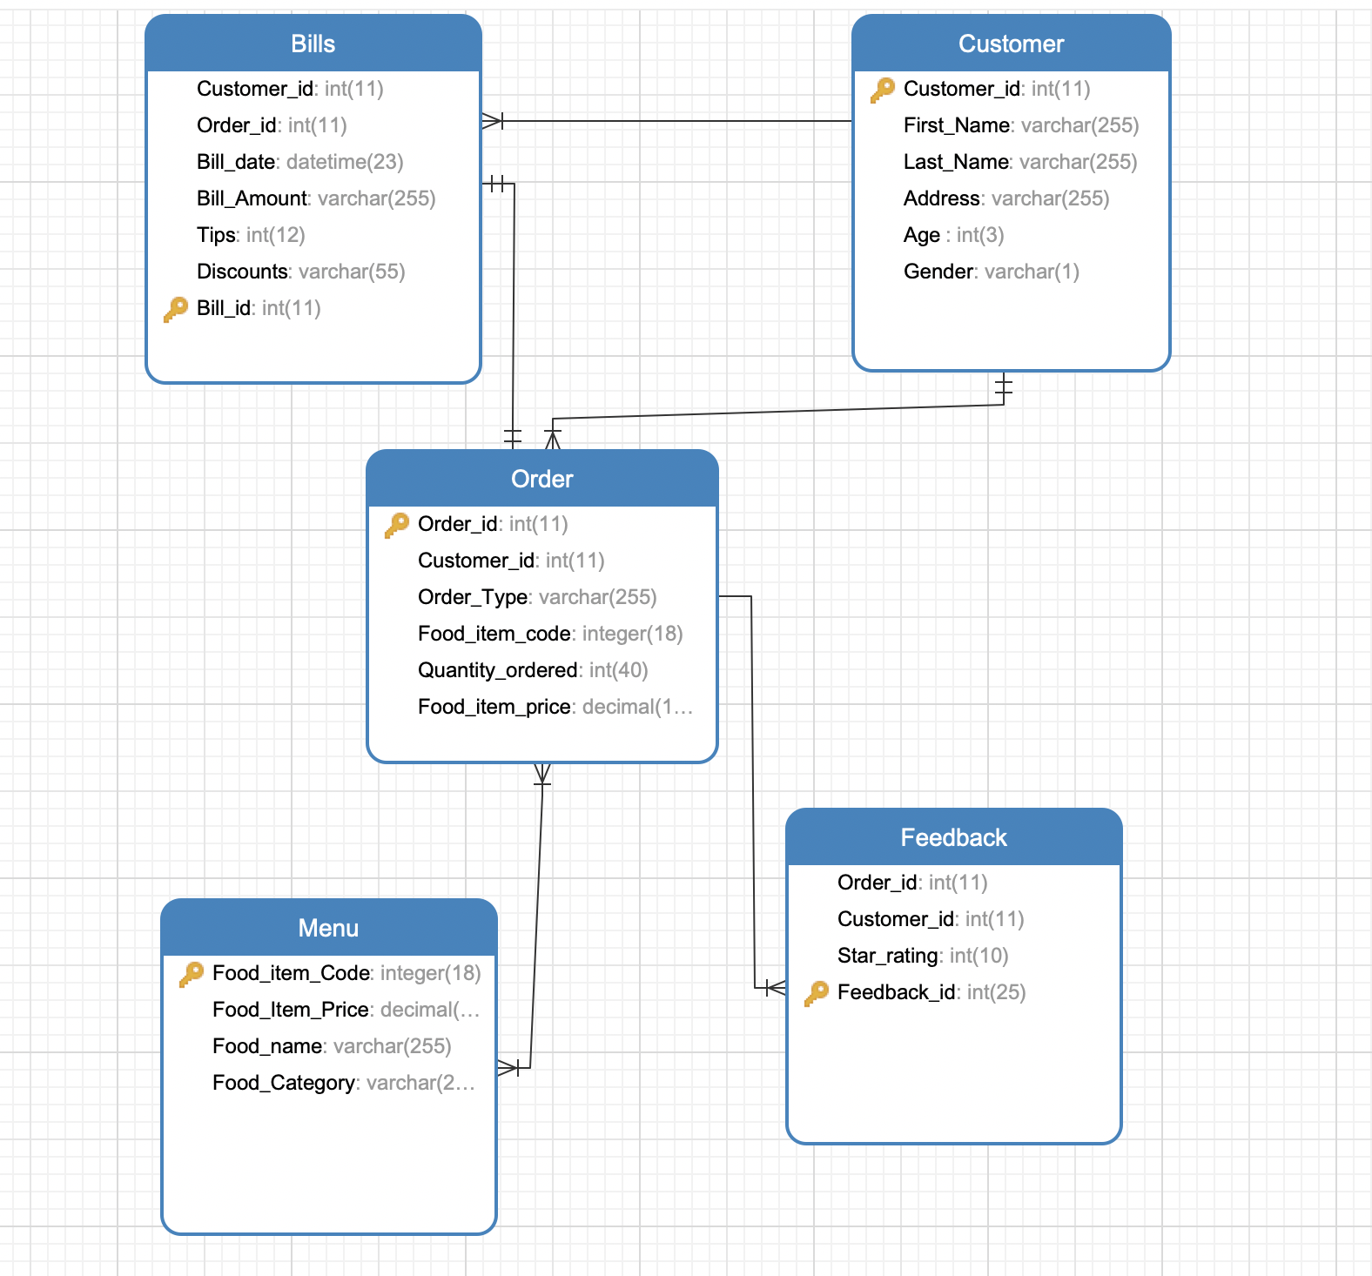

**Overall Screenshot in Navicat:**

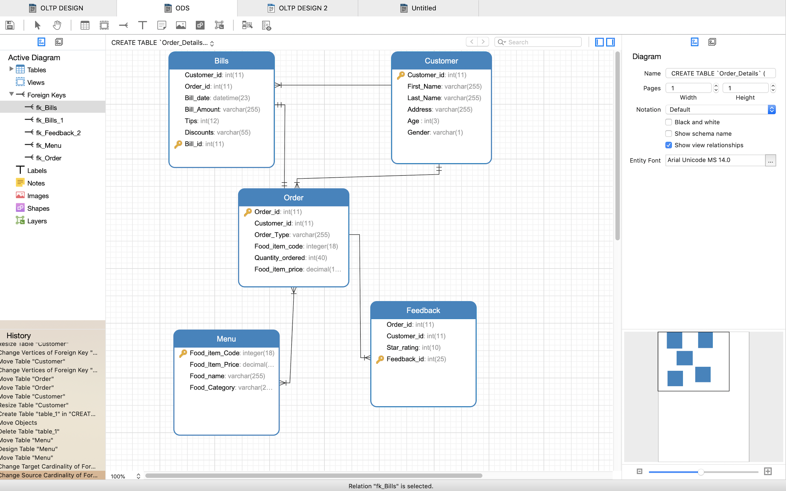

**DW Schema (Facts & Dimensions):** We designed the OLAP schema for our restaurant management in ERWIN. There are six Dimension tables and one fact table. The Dimension tables are:

1. Customer
2. Orders
3. Menu
4. Bill
5. Feedback
6. Date

**Please find the screenshot of OLAP Schema Design below:**

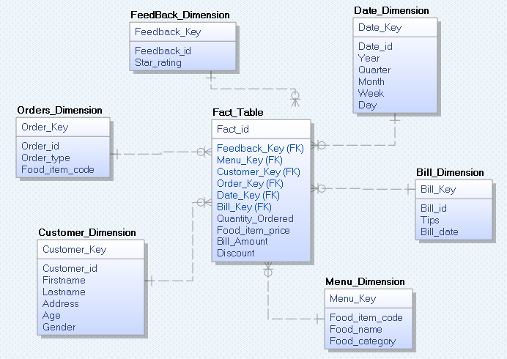

**Overall screenshot in ERWIN Model:**

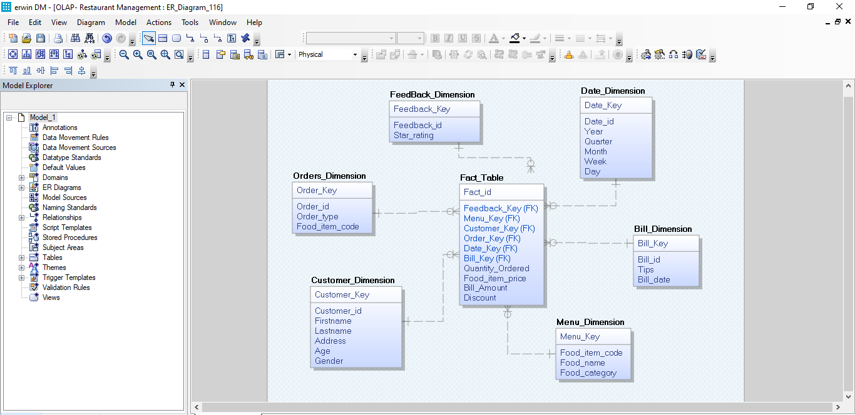

**Two sources for ETL Design:**

1. Feedback Table in Excel Format
2. Menu Table in CSV Format.

These two files are attached in assignment. They are generated from generatedata.com.